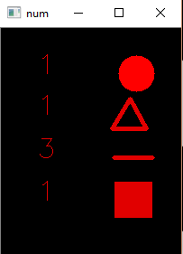Task 2:

Algorithm

we suppose to detect the numb of the species and show them on a black screen with red shapes.

The way we do that is by converting the image to gray, then threshold   
then find the contours around the object that he found

And by counting the numb of the lines that construct each object we can identify each shape

Steps to run the code :  
  
Open the folder as Edit with IDLE

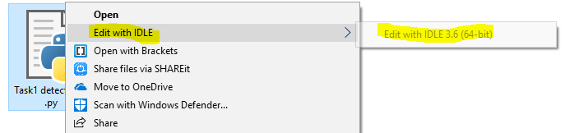

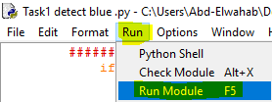

Run > Run module   
OR  
F5

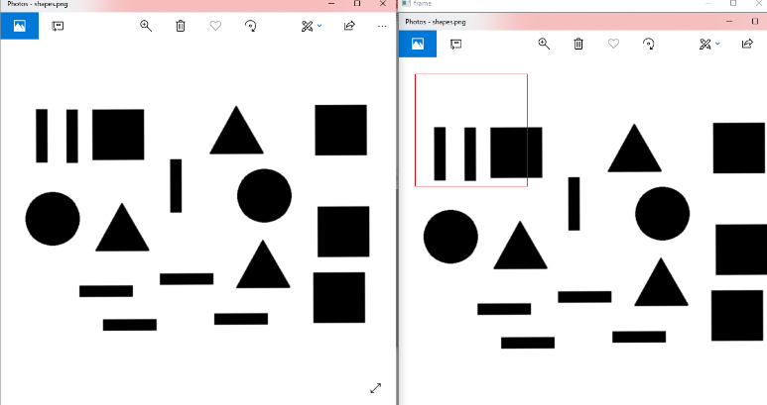Then a red rectangle will be shown on the right part of the screen

We can control the position by 2,4,6,8 bottoms

And the Area of it by +,-

After adjust the red rectangle to contain all the shapes we desire

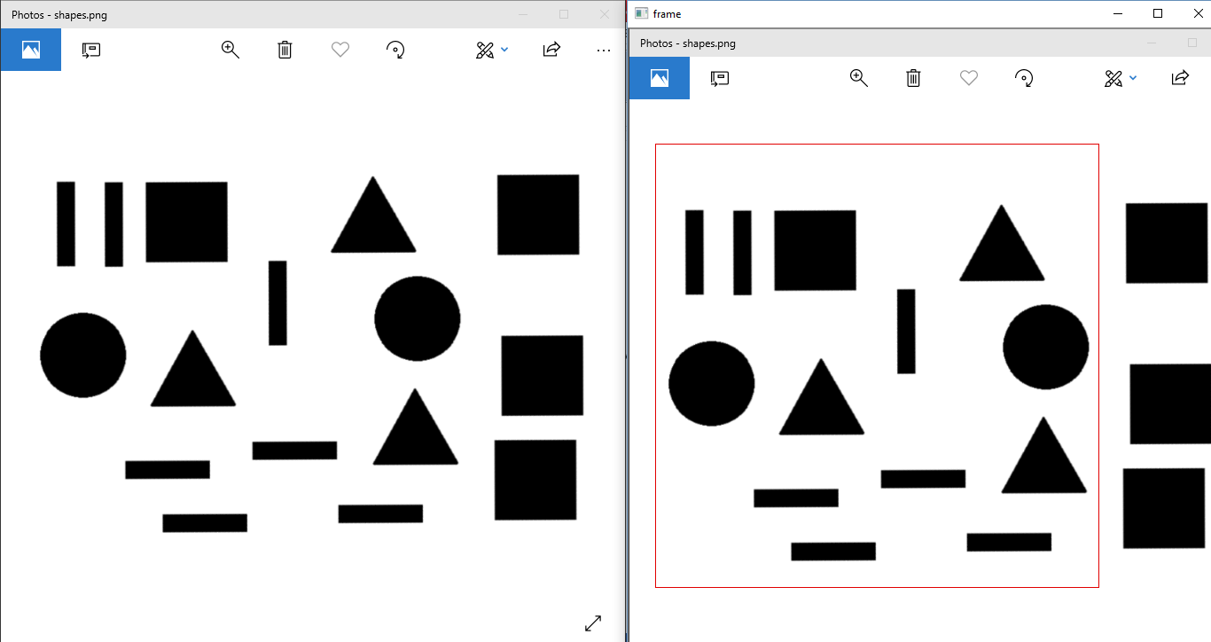

We will press “U” on the Frame window

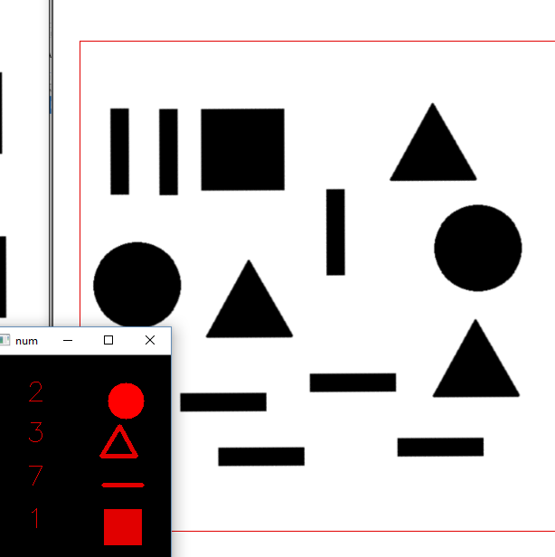A new window will be opened

Contain the exact numb of the species

And another one with the same object with contour around it.

